William Watlington

November 6, 2022

WEB 425

Assignment 3.4 – Guarding Routes

Login:

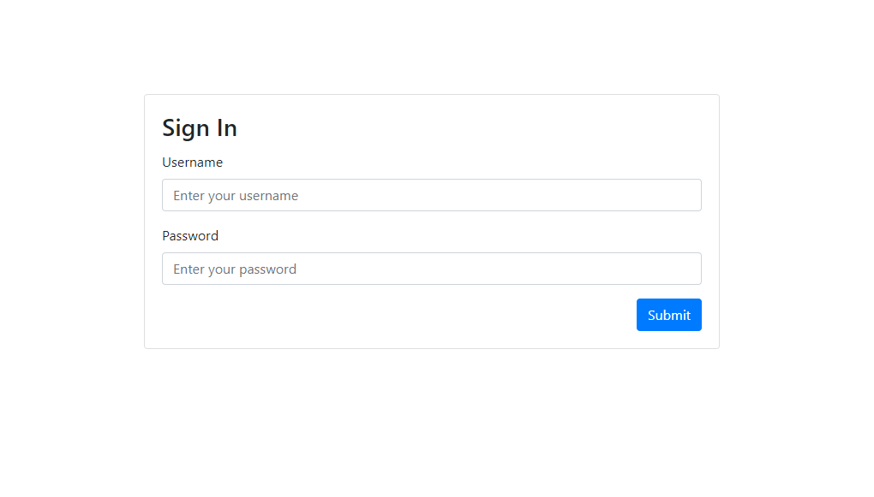

Profile Page:

